University of the People

CS4404 Advanced Networking and data security

Unit 5 Written Assignment 5

Anonymous Student

Your organization has recently become aware of potential ICMP related attacks on its network and has tasked you with investigating this issue. As part of your investigation, you are to analyze ICMP traffic patterns in the network to gain a better understanding of the situation. One aspect of this investigation will involve looking at ICMP messages generated by Ping programs. In particular, you will be tasked with answering the following questions:

**Introduction**

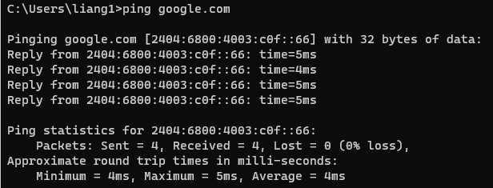

Ping Google.com

**ICMP request**

The IP6 address is 2404:6800:4003:c0f::66:

Filter icmpv6S

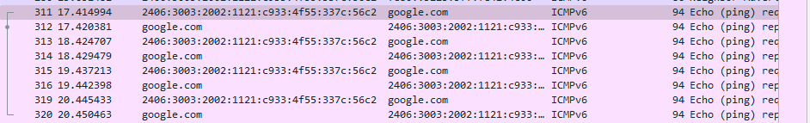

Address and protocol is ICMPv6

Type: Echo (ping) request (128)

Code: 0

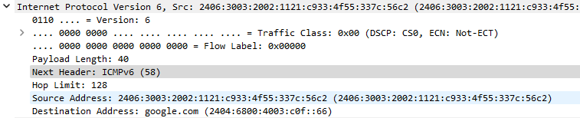

Check sum and identifier

0xd41f status is correct

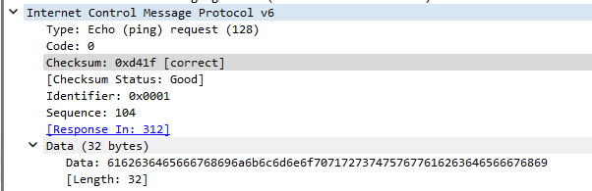

**ICMP reply**

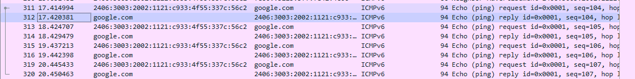

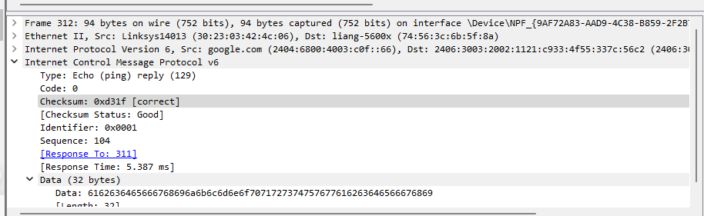

Type is Type: Echo (ping) reply (129) Code: 0

Checksum and identifier are 6 bytes each

Tracert

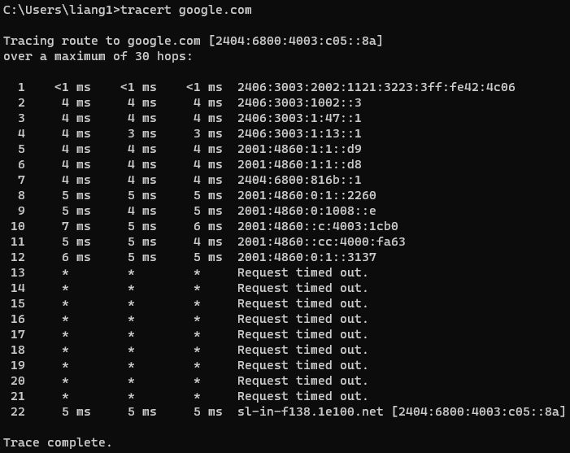

Traceroute capture

ICMP type 128 code 0

My Ip address

2406:3003:2002:1121:3223:3ff:fe42:4c06

Target IP address sl-in-f138.1e100.net [2404:6800:4003:c05::8a]

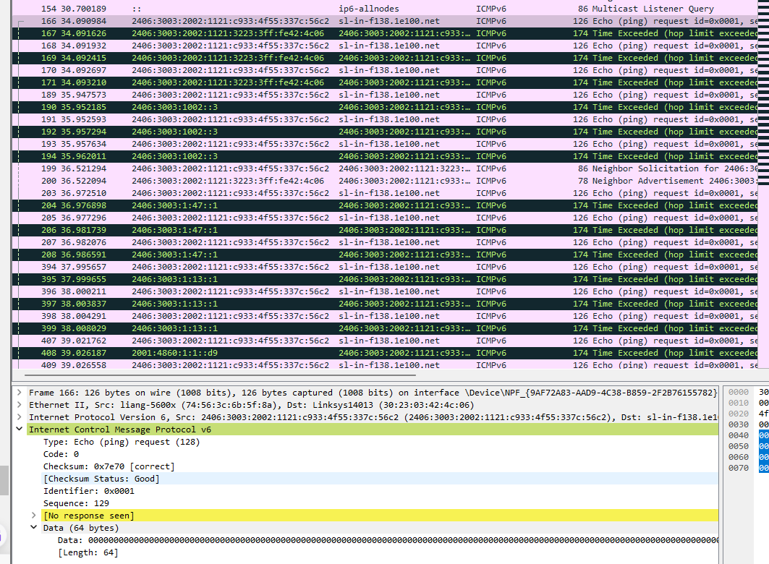

**Conclusion**

Overall, through this practical, I have learned how to navigate the captured packets and the requests. I am able to lookup for route address from host and destination.

**Reference**

*Wireshark User’s Guide*. (n.d.). Retrieved November 19, 2023, from https://www.wireshark.org/docs/wsug_html_chunked/index.html